



Data Structures & Algorithm
LAB MANUAL

Disclaimer: The content is curated from online/offline resources and used for educational purpose only
Arrays in Python
Objective:
To understand the concept and usage of arrays in Python.
Equipment Required:
Computer with Python installed, text editor/IDE.
Prerequisites:
Basic understanding of variables, loops, and data types.
Problem Statement:
Define an array and explain its use with a simple program to store and display 5 integers.

Procedure:

Program 1: Define an array and explain its use with a simple program to store and display 5 integers.
- Open your Python environment (IDE or text editor).

Disclaimer: The content is curated from online/offline resources and used for educational purpose only
- Define a list to act as an array with 5 integers.
- Use a loop to display each element of the array.
- Explain how using an array makes it easier to store and manage a group of values of the same type.
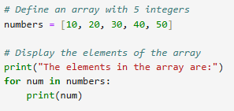

Output:
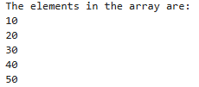
Program 2: Write a program to find the average of n numbers stored in an array.
- Take input from the user for the number of elements (n).
- Initialize an empty list (array).
- Use a loop to take n inputs and append them to the list.
- Calculate the sum of the elements using sum() function.
- Divide the sum by n to get the average.
- Display the result.
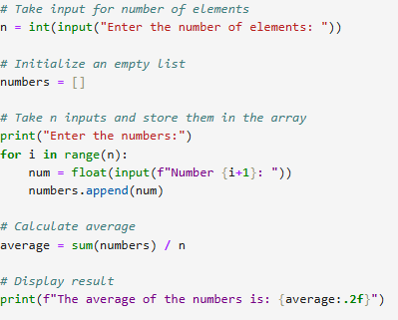
Output:
